# Lesson 1

from turtle import *

pendown()

bgcolor('black')

color('red')

width(3)

left(90)

fd(50)

left(90)

color('green')

fd(100)

color('white')

fd(100)

width(10)

fd(100)

left(90)

width(1)

fd(100)

width(50)

fd(100)

# Lesson 2

from turtle import *

pendown()

bgcolor('black')

color('red')

fd(50)

right(90)

hideturtle()

fd(100)

showturtle()

right(90)

penup()

fd(100)

right(90)

pendown()

fd(50)

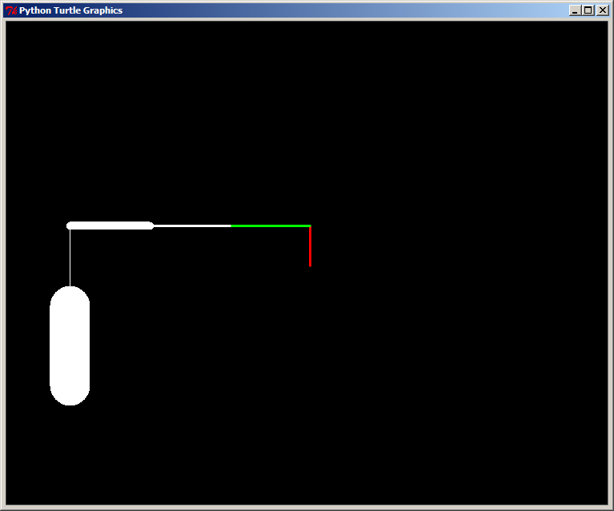

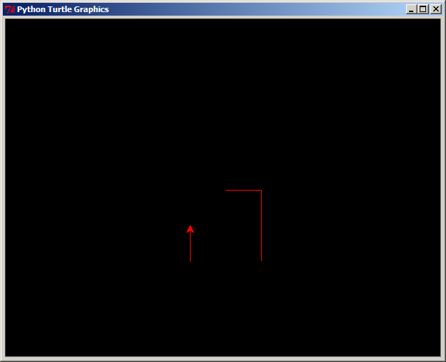

# Lesson 3

from turtle import *

pendown()

bgcolor('black')

width(3)

color('red')

for i in range(3):

fd(100)

right(360/3)

color('white')

for i in range(4):

fd(100)

right(360/4)

color('blue')

for i in range(5):

fd(100)

right(360/5)

left(90)

for i in range(40):

width(i)

fd(4)

color('red')

width(3)

for i in range(36):

fd(10)

right(10)

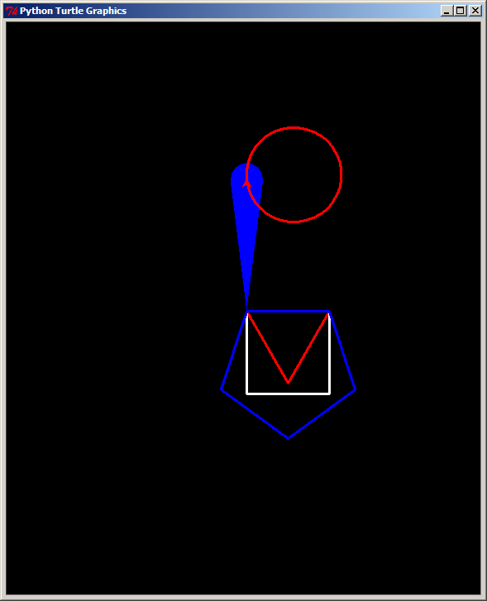

# Lesson 4_1

from turtle import *

pendown()

bgcolor('black')

width(3)

color('red')

for i in range(36):

for j in range(36):

fd(10)

right(10)

right(10)

# Lesson 4_2

from turtle import *

pendown()

bgcolor('black')

width(3)

color('red')

def polygon(n):

for i in range(n):

fd(50)

right(360.0/n)

polygon(5)

for i in range(3,10):

polygon(i)

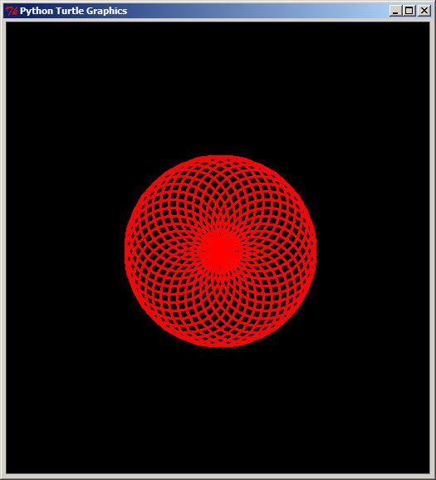

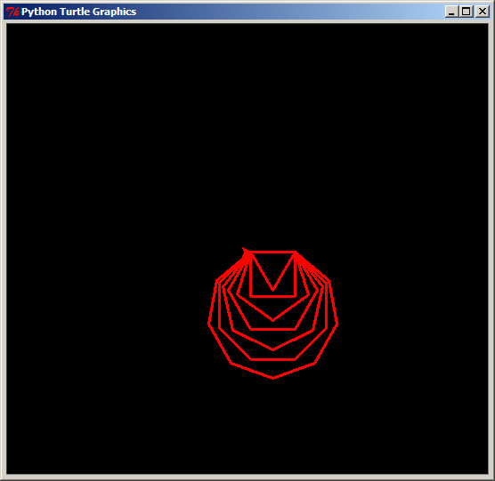

# Lesson 4_3

from turtle import *

pendown()

bgcolor('black')

width(3)

color('red')

def polygon(n):

for i in range(n):

fd(50)

right(360.0/n)

for i in range(3,15):

polygon(i)

right(30)

# Lesson 4_4

from turtle import *

pendown()

bgcolor('black')

width(3)

def circle():

for i in range(36):

fd(10)

right(10)

color_list=['red', 'green', 'blue', 'purple', 'orange', 'yellow']

for item in color_list:

color(item)

circle()

right(60)

